Use of Cl/Br ratio to determine salinity source of groundwater: Lenjanat plain, Isfahan, Iran
Hamid Reza Nassery, Zahra Kayhomayoon

Faculty of Earth Sciences
Shahid Beheshti University
Tehran, Iran
H-Nassery@sbu.ac.ir, Z_Kayhomayon@sbu.ac.ir

Abstract: Ratio of conservative ions Cl/Br has been used to identify source of groundwater salinity in Lenjanat plain. For this purpose, groundwater was seasonally sampled. The results of field and laboratory measurements show that Chloride ion as an indicator of groundwater salinity, highly correlated with EC and elements Mg، Ca، Br and Sr. Concentration of chloride a gradually increase through groundwater flow direction of the borders (17.73 mgl⁻¹) towards the middle parts ( 3475 mgl⁻¹) of the plain. The trend of Br concentration changes is similar with Cl. Mass ratios of conservative elements Cl/Br for groundwater samples in Lenjanat plain is 329 in borders to 4492 in center of plain. Certain ratios and saturation index with geochemical graphs indicate that the dissolution of evaporation deposits (halite and gypsum) and cation exchange are the most important processes affecting the chemical composition of groundwater. According to these results, the data obtained from the ratio of Cl/Br in Lenjanat groundwater samples, confirms the reported Cl/Br ratio for groundwater affecting by the dissolution of evaporation deposits and overlap with range of Cl/Br ratio for domestic sewage effluent groundwater.
Keywords: Groundwater salinity, Cl/Br ratio, Lenjanat plain.

1. Introduction
There are various salinity sources for groundwater. Some of these are more dominant than others and individually sources may be active in some place but not in another depending on natural conditions and changes induced by man. Individual salinity sources judged as most important on a regional level are (1) naturally occurring saline ground water, (2) halite solution, (3) sea-water intrusion, (4) oil-field and gas-field brines, (5) agricultural by-products and techniques, (6) saline seep, and (7) road salt [1]. To determine the source of groundwater salinity, geochemical [2, 3, 4, 5, 6] and geophysical methods [7, 8, 9] are more used. In areas where more than one possible source of groundwater salinity exists, geochemical methods (isotopic and non-isotopic) have proven valuable for identifying salinity sources.
In geochemical methods, chemical constituents and constituent ratios are used as tracers of groundwater salinity sources (Table 1). In non-isotopic geochemical methods, hydrogeochemical information contained in natural groundwater can be considered essentially in two categories: 1) those parameters which are inert and therefore serve as indicators or tracers of input conditions (either internal or external) such as Cl and 2) those which are reactive and which record the processes taking place as a result of interaction between water and rock such as common cations. Some reactive tracers may be attenuated during flow from the input source, whilst others increase in concentration with time, unless or until their concentrations are limited by mineral saturation or other geochemical controls [10].
Ratio of Cl to Br is one of the important indicators in identifying the sources of groundwater salinity and in determining brines evolution. Chemical characteristics of these elements are similar and generally act conservatively in ionic form. Nevertheless, assuming them to be conservative poses obvious limitations on the interpretation of some data [2, 3], particularly for Br due to absorption by fine grain deposits (clay and shale). According to investigations made in different areas, the Cl/Br ratio obtained for seawater is about 290, precipitation is less than 200, the brines upconing (relics of evaporated seawater) is less than 300 (oil field brines less than 400), the evaporate rocks containing halite are generally greater than 300 (most commonly greater than 1000), the domestic sewage is 300 to 900 (with a mean of 732), the sewage-contaminated groundwater is between 150 to 540, and agricultural return-flow is less than 200 [2, 3, 11, 12].

Table 1. Geochemical parameters used for identification of salinity sources [13]
Salinization Sources | Chemical Parameter
Natural saline water  versus others | Cl, Br, I, S-34, ¹⁸O, D, Br/Cl, Na/Cl, I/Cl, I  Mg/Cl, K/Cl, Ca/Cl, (Ca+Mg)/SO₄, Sr
Halite-solution brine  versus others | K/Na, Br/TDS, (Ca+Mg)/(Na+K), Na/Cl,  Ca/Cl, Mg/Cl, SO₄/Cl, Br/Cl, K/Cl  (Ca+Mg)/SO₄, I/Cl, ¹⁸O/D, I/Cl, SO₄ /(Na+K)  SO₄/TDS, SO₄/Cl
Seawater intrusion versus others | Cl, Major ions (Piper), ¹⁴C, ³H, I/Cl, B, Ba, I  ¹⁸O, ²H, ¹³C, Ca/Mg, Cl/SO₄, B/CI, Ba/Cl  Br/Cl
Oil-field brines versus others | Cl, Major ions, Na/Cl, Ca/Cl, Mg/Cl, SO₄/Cl  Br/Cl, I/Cl, Major ion ratios, Cl, Br  (Na+Cl)/TDS, Li/Br, Na/Br, Na/Cl, Br/Cl
Agricultural effluents versus others | Cl, NO₃, Cl/NO₃, K, TDS
Saline seep versus others | SO₄, Ca/Cl, Mg/Cl, SO₄/C1, NO₃
Road salt versus others | Cl, Major Ion ratios, Br/Cl, Dye
In Lenjanat plain, industrial and agricultural water supply is from Zayandehrud river and water demanded for agriculture (except for agricultural land along the river) and livestock is provided by groundwater resources. Agriculture is performed as double planting (spring and autumn) and flooding irrigation in the plain. In recent years, because of groundwater salinization, agricultural activities has limited to planting of cereals (barely, wheat, alfalfa, and clover) in Lenjanat plain. In this study, the source of groundwater salinity in Lenjanat plain has been identified using Cl/Br ratio.
2. Study area
The study area with 1230 square kilometer located in Lenjanat plain, southwest of Isfahan Province, Iran (Fig. 1). Lenjanat plain area is approximately 1700 square kilometer and its average altitude is 1800 meters. This plain is sub-basin of Zayandehrud river. Lenjanat climate is semiarid in west to south and is arid in other regions. Geological deposits age in Lenjanat plain is during Permian to Quaternary [14, 15].

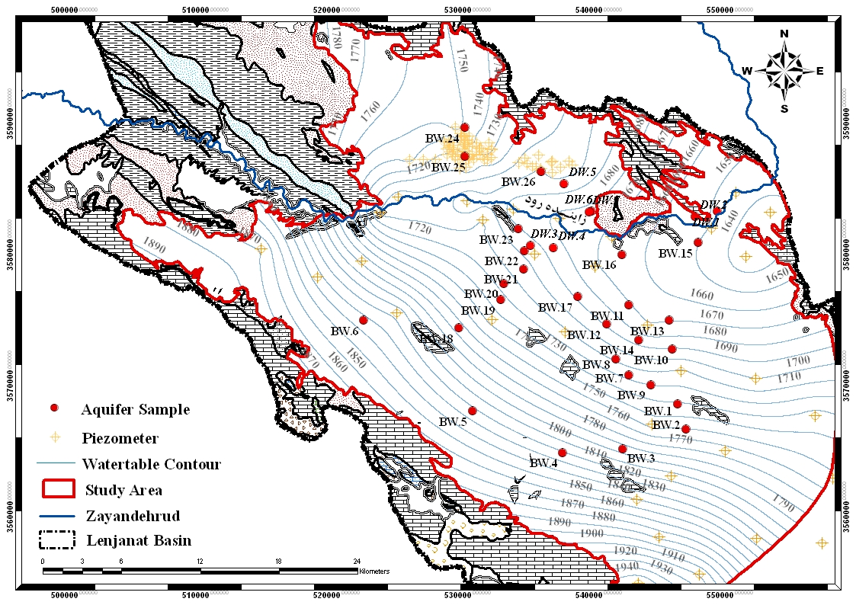

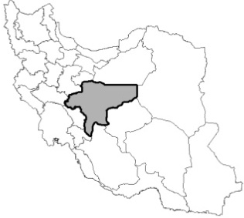
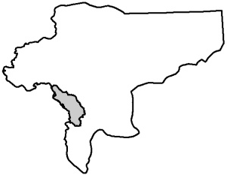
Isfahan province

Figure 1. Geological map, water table contours and groundwater sampling point in the study area

The most important outcrop in mountains is Jurassic shale and widely thick layer Cretaceous limestone. The aquifer bedrock is Jurassic shale and, in some area, Cretaceous limestone. Alluvial deposits are clay (at least 50 percent), sand and gravel. Evaporate layers with gypsum and salt crystals have been deposited among the alluvium. Percentage of salt and clay deposits is higher in bottom layers [16, 17, and 18]. Main source of aquifer recharge is limestone and crushed thick layers of Cretaceous in mountains (especially from west to south). General direction of the groundwater flow is from west to east, following the overall basin slope (Fig. 1). Maximum depth of water table in the study area is 50 meters (east of the area) and its minimum is about 1 meter (adjacent to the river).
3. Materials and methods
To study the chemical composition of groundwater and identify salinity source, 132 water samples were collected from the 33 groundwater resource (agricultural, domestic and ranch wells). Sampling was performed seasonally in May, August, November and February (2008-2009). Sampling points are selected according to the groundwater flow direction in the plain (Fig. 1). Method of sampling has been conducted in accordance with [19] and [20] guidelines. In each sample, 92 elements and parameters were measured (Table 2).
The data obtained from field and laboratory measurements in Lenjanat groundwater samples were evaluated considering variation range in similar geological environments [21]. The distribution of major ions and correlation matrix were constructed with SPSS Statistics 18.0 (SPSS Statistics, 2010). The data of groundwater analysis were plotted on hydrogeochemical diagrams with AqQA 1.5 (RockWare Inc., 2007). The variations of element concentrations and parameter values in aquifer were illustrated on zoning maps through Surfer 9.5 (Golden Software Inc., 2010) and Arc GIS 9.3 (ESRI, 2010). For recognition of the active chemical reactions in the aquifer, saturated index was calculated by PHREEQC software [22].

Table 2. Parameters and elements measured in Lenjanat groundwater samples
 | Parameter | Detection Limit |  | Analysis Method | Instrument
In field | pH, ORP |  | 0.01, 1 mV | pHmeter | WTW- pH 315i, WTW- MultiLine P4
 | EC, Salinity |  | 1 μS/cm, 0.1 | ECmeter | WTW - Cond 315i
 | DO |  | 0.01 mg/l, 0.1% | DOmeter | WTW- MultiLine P 4
 | Temp. |  | 0.1 °C | pH, EC & DOmeter | WTW
In Abfa Lab | F |  | 0.01 mg/l | Spectrophotometer | Shimadzu - UV 190
 | Cl |  | 1.77 mg/l | Titration | ─
 | SO₄ |  | 0.5 mg/l | Spectrophotometer | Shimadzu - UV 190
 | SO₃ |  | 0.05 mg/l | Titration | ─
 | S |  | 0.02 mg/l | Titration | ─
 | CO₃ |  | 1.5 mg/l | Titration | ─
 | HCO₃ |  | 3.05 mg/l | Titration | ─
 | NO₂ |  | 0.001 mg/l | Spectrophotometer | Shimadzu - UV 190
 | NO₃ |  | 0.5 mg/l | Spectrophotometer | Shimadzu - UV 190
 | NH₄ |  | 0.2 | Kjeldahl Method | ─
 | PO₄ |  | 0.001mg/l | Spectrophotometer | Shimadzu - UV 190
 | TH |  | 2.5 mg/l | Titration | ─
 | Alka. |  | 2.5 mg/l | Titration | ─
 | COD |  | 0 mg/l | Dry Thermostat Reactor | HACH - DRB 200
 | TOC |  | 0.01 mg/l | TOCmeter | Shimadzu - TOC-V_{CSH}
 | Total Coliform |  | MPN/100 mL | Fermentation tubes | ─
 | Feacal Coliform |  | MPN/100 mL | Fermentation tubes | ─
In Act Lab | Ag, Al, As, Au, B, Ba, Be,Bi, Br, Ca, Cd, Ce, Co, Cr, Cs, Cu, Dy, Er, Eu, Fe, Ga, Gd, Ge, Hf, Hg, Ho, I, In, K, La, Li, Lu, Mg, Mn, Mo, Na, Nb, Nd, Ni, Os, Pb, Pd, Pr, Pt, Rb, Re, Ru, Sb, Sc, Se, Si, Sm, Sn, Sr, Ta, Tb, Te, Th, Ti, Tl, Tm, U, V, W, Y, Yb, Zn, Zr | 0.001 -200 µg/l |  | ICP-OES & MS | Perkin Elmer Sciex Elan

4. Results and Discussion
The results of physicochemical parameters analysis of Lenjanat groundwater samples are presented in Table 3. In study area, EC values increases with distance from mountains and it reaches to maximum (>6000 µS/cm) in center of plain (Fig. 2). The results of samples analysis show that the high values of EC (561-11390 μS/cm) in groundwater is due to high concentrations of major elements. Na, Ca, Cl and SO₄ ions have the higher concentration than others in all seasons. Chloride ion has the highest concentration. Among the minor and rare elements measured, B, Li, Br, Sr, I, Ba, F, and Si had higher concentrations than others, which have been used in the interpretation of the results.
The hydrogeochemical facies varies from HCO₃-Ca in recharge area (near by mountains) to Cl-Ca in central area of Lenjanat plain. With consideration to high concentration of Cl in Lenjanat groundwater (18 - 3475 mgL⁻¹), classification based on the salinity or Cl concentration was used [23]. On this basis, Lenjanat groundwater is placed in all five categories that include oligohaline (Cl: 5-30 mgL⁻¹), Fresh (30-150 mgL⁻¹), Fresh-Brackish (150-300 mgL⁻¹), Brackish (300-1000 mgL⁻¹) and Brackish-Salt (1000-10000 mgL⁻¹). The two recent classes have more frequency (Fig. 3).
The presence of evaporate deposits as crystals and layers of gypsum and halite in the aquifer alluvium have been reported [16, 17, 18, 24]. Based on this, ion ratios and saturation indexes have been used for determining source rock and recognizing the active chemical reactions in Lenjanat aquifer. Considering to the high concentrations of major elements in Lenjanat groundwater and the presence of silty-clay soils, gypsum and salt in the aquifer deposits [17, 18] mass ratios include Na/(Na+Cl), Ca/(Ca+SO₄), Mg/(Ca+Mg), HCO₃/∑Anions and (Ca+Mg)/SO₄ were used [25]. These ratios were calculated seasonally, and dominant process in the groundwater samples was determined with considering an uncertainty of ±0.1 (Table 4). Because of no significant seasonal variation in major ion concentrations, processes in each sample were dominant at least in three seasons.
Regarding the geological deposits in the study area can be assumed that primary source of chloride in the groundwater is sodium chloride (directly from halite dissolution) and primary source of sulfate is direct dissolution of gypsum (or anhydrite). Accordingly, in most samples the dissolution of halite (Na/Na+Cl=0.5) and gypsum (Ca/Ca+SO₄=0.5, HCO₃/∑Anions<0.8) is predominant. Dissolution of carbonates (Mg/Ca+Mg<0.5) is also a significant process in the aquifer. Saturation index calculated through geochemical modeling (Table 5) also indicates a suitable chemical environment for halite and gypsum dissolution (negative saturation index) and calcite precipitation (positive saturation index).
Ion ratio of Na/(Na+Cl)>0.5 has been obtained in Lenjanat groundwater samples with SO₄-Na facies that indicates a Na source other than halite, such as albite (plagioclase), or natural softening. Due to negligible expansion of igneous rocks in Lenjanat basin and abundance of silty-clay deposits in the plain, cation exchange has increased Na concentration in groundwater. The highest cation exchange capacity available to groundwater is in sediment organic matter, iron and manganese oxides and hydroxides and clay minerals, respectively [26]. Because of slight amounts of organic matter (Total Organic Carbon<5 mgL⁻¹) and oxides and hydroxides of iron and manganese (Fe_{Total}<1 mgL⁻¹, Mn<0.1 mgL⁻¹) in Lenjanat aquifer deposits, CEC is limited to clay minerals. Ratio of Na/ (Na+Cl) < 0.5 indicates the decrease of Na concentration in the study samples. Only common cause of reduction of sodium in groundwater is reverse ion exchange process which occurs when salty water (TDS>500) containing sodium is in contact with Ca rich clays (usually Montmorillonite). When saline groundwater (with high activity) enters an environment with a lower degree of groundwater salinity (softener), Na is replaced with Ca and Mg [27].

Table 3. Results of physicochemical parameters measured in groundwater samples
Parameter | Units | Range of values | Groundwater quality
EC | µS/cm | 561- 11390 | Existence of soluble deposits in aquifer
TDS | mg/l | 309 - 7440 | Saline to slightly saline
pH |  | 6.5 - 7.8 | Neutral to slightly basic
ORP | mV | +118.8 - +232.9 | Relatively Oxide
DO | mg/l | 2.34 - 11.87 | Aerobic environment
TOC | mg/l | 0.156 - 4.241 | Organic-poor groundwater
COD | mg/l | 0 - 58 | Organic-poor groundwater
BOD₅ | mg/l | 0 - 8 | Organic-poor groundwater
TH | mg/l CaCO₃ | 125 - 200 | Hard to very hard  Temporary hardness (carbonate)
Alka. | mg/l CaCO₃ | 0 (CO₃)  55 – 500 (HCO₃) | Neutral geochemical environment (Buffering), Sedimentation
Temp. | °C | 10 - 23 | Annual mean of weather temperature

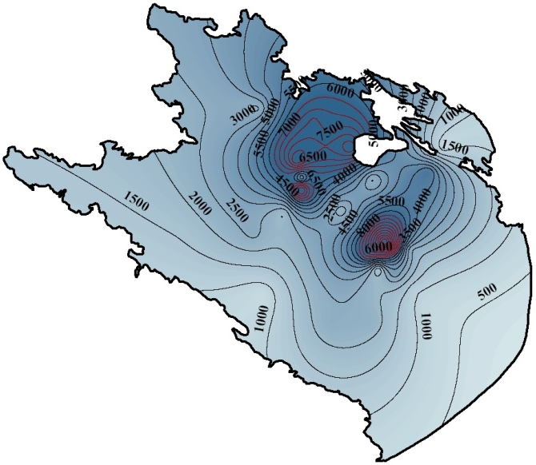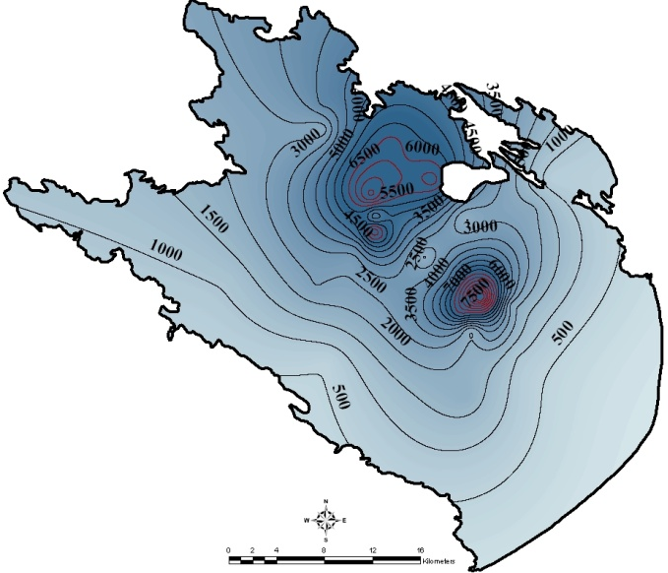
Winter
Spring
Figure 2. Zoning map of EC variations in Lenjanat plain (The red line shows EC>6000 µS/cm)

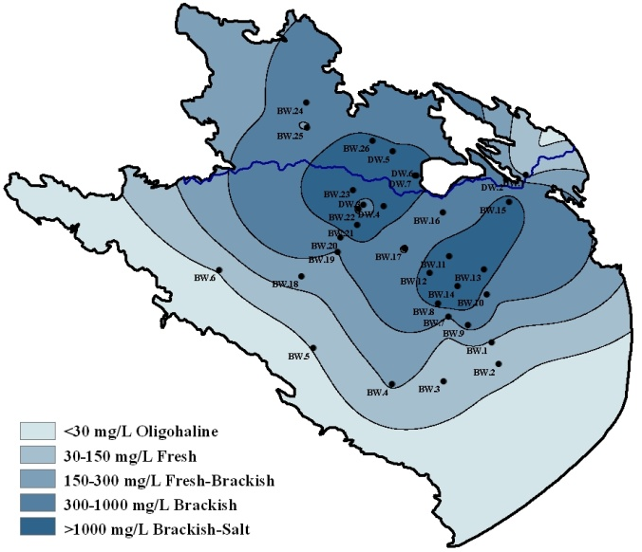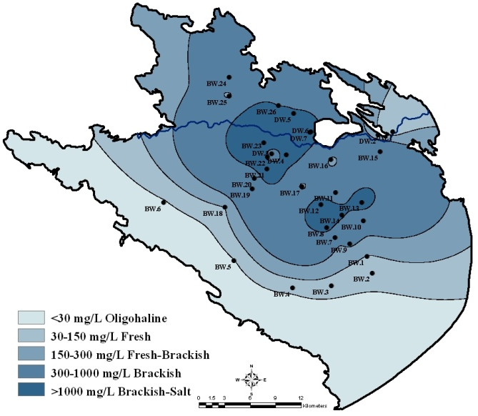
Winter
Spring

Figure 3. The variation of chloride ion concentration in Lenjanat groundwater

This ratio has created Cl-Ca facies in wells at central part of Lenjanat plain that directly indicates groundwater salinization. The high concentrations of Ca and Mg in study groundwater are due to limestone outcrops and carbonate gravels in the area that determined by Mg/Ca+Mg < 0.5 ratio.
Halite deposits are often associated with gypsum and anhydrite sediments. Considering the neutral pH of Lenjanat groundwater, Ca/ (Ca+SO₄) <0.5 is due to decrease of Ca concentration in groundwater (calcite precipitation or ion exchange process), whereas Ca/ (Ca+SO₄)>0.5 is due to increase of Ca concentration which results in dissolution of carbonate or silicate deposits (a source other than gypsum dissolution). This process is in accordance with reverse softening in the study aquifer. In summary, waters recharge into the aquifer from limestone formations and carbonate deposits of the plain containing calcium and bicarbonate ions and elements such as Mg and Sr (impurities of calcite).
Positive saturation index for calcite shows that this mineral potentially could begin the precipitation. In other words, the weak supersaturated environment for calcite is due to presence of sulfate minerals in the aquifer deposits and De-dolomitization process [28]. In this study, slightly negative saturation index for dolomite indicates appropriate conditions for dissolution of this mineral.

Table 4. Ion ratios were used in recognition of source-rock in Lenjanat aquifer

 | Annual Average of Certain Ratio
Sample | Na/(Na+Cl) | Ca/(Ca+SO₄) | Mg/(Ca+Mg) | HCO₃/∑Anions | (Ca+Mg)/SO₄
BW.1 | Halite Solution | Gypsum Dissolution | Limestone-Dolomite Weathering | Evaporates or Brine
BW.2 | Halite Solution | Ca Sources other than Gypsum | Limestone-Dolomite Weathering | Evaporates or Brine
BW.3 | Ion Exchange | Calcite Removal (IE) or Precipitation | Limestone-Dolomite Weathering | Evaporates or Brine | De-Dolomitization
BW.4 | Ion Exchange | Calcite Removal (IE) or Precipitation | Limestone-Dolomite Weathering | Evaporates or Brine
BW.5 | Ion Exchange | Ca Sources other than Gypsum | Limestone-Dolomite Weathering | Evaporates or Brine
BW.6 | Ion Exchange | Calcite Removal (IE) or Precipitation | Limestone-Dolomite Weathering | Evaporates or Brine
BW.7 | Ion Exchange | Calcite Removal (IE) or Precipitation | Limestone-Dolomite Weathering | Evaporates or Brine | De-Dolomitization
BW.8 | Halite Solution | Gypsum Dissolution | Limestone-Dolomite Weathering | Evaporates or Brine | De-Dolomitization
BW.9 | Halite Solution | Gypsum Dissolution | Limestone-Dolomite Weathering | Evaporates or Brine | De-Dolomitization
BW.10 | Halite Solution | Gypsum Dissolution | Limestone-Dolomite Weathering | Evaporates or Brine | De-Dolomitization
BW.11 | Reverse Softening | Ca Sources other than Gypsum | Limestone-Dolomite Weathering | Evaporates or Brine | De-Dolomitization
BW.12 | Reverse Softening | Ca Sources other than Gypsum | Limestone-Dolomite Weathering | Evaporates or Brine | De-Dolomitization
BW.13 | Reverse Softening | Ca Sources other than Gypsum | Limestone-Dolomite Weathering | Evaporates or Brine
BW.14 | Reverse Softening | Ca Sources other than Gypsum | Limestone-Dolomite Weathering | Evaporates or Brine | De-Dolomitization
BW.15 | Halite Solution | Gypsum Dissolution | Limestone-Dolomite Weathering | Evaporates or Brine
BW.16 | Halite Solution | Gypsum Dissolution | Limestone-Dolomite Weathering | Evaporates or Brine | De-Dolomitization
BW.17 | Halite Solution | Gypsum Dissolution | Limestone-Dolomite Weathering | Evaporates or Brine | De-Dolomitization
BW.18 | Ion Exchange | Calcite Removal (IE) or Precipitation | Limestone-Dolomite Weathering | Evaporates or Brine | De-Dolomitization
BW.19 | Halite Solution | Gypsum Dissolution | Limestone-Dolomite Weathering | Evaporates or Brine | De-Dolomitization
BW.20 | Halite Solution | Gypsum Dissolution | Limestone-Dolomite Weathering | Evaporates or Brine | De-Dolomitization
BW.21 | Halite Solution | Gypsum Dissolution | Limestone-Dolomite Weathering | Evaporates or Brine | De-Dolomitization
BW.22 | Halite Solution | Gypsum Dissolution | Limestone-Dolomite Weathering | Evaporates or Brine | De-Dolomitization
BW.23 | Reverse Softening | Ca Sources other than Gypsum | Limestone-Dolomite Weathering | Evaporates or Brine
BW.24 | Ion Exchange | Calcite Removal (IE) or Precipitation | Limestone-Dolomite Weathering | Evaporates or Brine | De-Dolomitization
BW.25 | Ion Exchange | Calcite Removal (IE) or Precipitation | Limestone-Dolomite Weathering | Evaporates or Brine | De-Dolomitization
BW.26 | Halite Solution | Calcite Removal (IE) or Precipitation | Limestone-Dolomite Weathering | Evaporates or Brine | De-Dolomitization
DW.1 | Halite Solution | Ca Sources other than Gypsum | Limestone-Dolomite Weathering | Evaporates or Brine
DW.2 | Halite Solution | Gypsum Dissolution | Limestone-Dolomite Weathering | Evaporates or Brine | De-Dolomitization
DW.3 | Halite Solution | Gypsum Dissolution | Limestone-Dolomite Weathering | Evaporates or Brine | De-Dolomitization
DW.4 | Halite Solution | Gypsum Dissolution | Limestone-Dolomite Weathering | Evaporates or Brine
DW.5 | Halite Solution | Calcite Removal (IE) or Precipitation | Limestone-Dolomite Weathering | Evaporates or Brine | De-Dolomitization
DW.6 | Halite Solution | Gypsum Dissolution | Limestone-Dolomite Weathering | Evaporates or Brine | De-Dolomitization
DW.7 | Halite Solution | Gypsum Dissolution | Limestone-Dolomite Weathering | Evaporates or Brine | De-Dolomitization

Table 5. Annual average of saturation indexes calculated for Lenjanat groundwater samples

 | BW.1 | BW.2 | BW.3 | BW.4 | BW.5 | BW.6 | BW.7 | BW.8 | BW.9 | BW.10 | BW.11
SI_{Calcite} | 0.17 | 0.12 | 0.11 | 0.38 | 0.19 | 0.16 | -0.03 | 0.1 | 0.26 | 0.1 | 0.15
SI_{Dolomite} | -0.01 | -0.09 | -0.06 | 0.39 | 0 | -0.35 | -0.38 | -0.12 | 0.2 | -0.15 | 0.02
SI_{Gypsum} | -1.33 | -1.49 | -0.82 | -0.69 | -1.71 | -1.18 | -1.26 | -0.3 | -0.42 | -0.58 | -0.21
SI_{Halite} | -6.43 | -6.95 | -6.16 | -5.58 | -7.39 | -6.84 | -5.55 | -4.64 | -5.61 | -5.68 | -5.01
 | BW.12 | BW.13 | BW.14 | BW.15 | BW.16 | BW.17 | BW.18 | BW.19 | BW.20 | BW.21 | BW.22
SI_{Calcite} | 0.27 | 0.08 | -0.1 | 0.22 | 0.22 | 0.06 | 0.22 | 0.32 | 0.12 | 0.15 | 0.16
SI_{Dolomite} | 0.21 | -0.12 | -0.41 | 0.09 | -0.04 | -0.18 | 0.21 | 0.2 | -0.05 | -0.03 | -0.26
SI_{Gypsum} | -0.6 | -0.35 | -0.04 | -0.71 | -0.53 | -0.66 | -0.84 | -0.91 | -0.6 | -0.19 | -0.6
SI_{Halite} | -4.97 | -5.07 | -4.29 | -5.31 | -6.08 | -6.07 | -5.85 | -5.65 | -5.23 | -4.4 | -4.96
 | BW.23 | BW.24 | BW.25 | BW.26 | DW.1 | DW.2 | DW.3 | DW.4 | DW.5 | DW.6 | DW.7
SI_{Calcite} | 0.17 | 0.26 | 0.24 | 0.34 | 0.12 | 0.17 | 0.26 | 0.01 | 0.17 | 0.26 | 0.27
SI_{Dolomite} | -0.14 | 0.29 | 0.21 | 0.34 | -0.35 | -0.03 | -0.15 | -0.47 | -0.03 | 0.17 | 0.06
SI_{Gypsum} | -0.32 | -0.71 | -1.09 | -0.26 | -1.35 | -0.78 | -0.5 | -0.48 | -0.41 | -0.16 | -0.05
SI_{Halite} | -4.37 | -5.2 | -5.69 | -4.56 | -6.79 | -5.93 | -5.74 | -4.76 | -4.61 | -4.49 | -4.52

In general, based on mentioned geochemical evidences, the gradual increase in major ions concentrations in Lenjanat at groundwater, as well as reports of presence of evaporate deposits in the aquifer, a natural trend is expected for chemical changes in path of groundwater flow. In other words, existing hydrogeochemical characteristics in Lenjanat aquifer are caused by water/rock interactions including cation exchange, dissolution of halite and gypsum, and carbonate precipitation-dissolution.
Ion ratios of conservative elements have been used to evaluate accuracy of these active reactions. Based on the studies done on other areas [ 2, 3; 11], the values of Cl/Br ratio in Lenjanat groundwater (Table 6) are in the range of the groundwater affected by evaporate rocks dissolution and sewage (Fig. 4).
The Cl/Br ratio obtained by [11] for sewage-contaminated groundwater is 150 to 540. On this basis, in wells B.W1 to B.W6 in Lenjanat plain, with Cl/Br ratio less than 600, the impact of domestic wastewater on groundwater is probable. These wells are located in southwest border of the plain (adjacent to mountains) and, due to their distance from population centers, groundwater contamination from domestic wastewater in these wells is very weakly probable. The study of Br, I, B and NO₃ concentrations with the bacteriological analysis in these wells indicate that domestic wastewater have no impact on groundwater salinity.

Table 6. Values of Cl/Br ratio in Lenjanat groundwater
 |  | BW.1 | BW.2 | BW.3 | BW.4 | BW.5 | BW.6 | BW.7 | BW.8 | BW.9 | BW.10 | BW.11
Cl /Br | Spring | 692 | 512 | 439 | 443 | 369 | 443 | 1638 | 1073 | 661 | 1087 | 613
 | Summer | 709 | 501 | 514 | 557 | 443 | 355 | 1702 | 1171 | 702 | 1093 | 2000
 | Autumn | 580 | 408 | 496 | 745 | 355 | 329 | 1694 | 1418 | 702 | 1141 | 1900
 | Winter | 594 | 464 | 634 | 553 | 394 | 512 | 1502 | 1005 | 778 | 1129 | 1981
 |  | BW.12 | BW.13 | BW.14 | BW.15 | BW.16 | BW.17 | BW.18 | BW.19 | BW.20 | BW.21 | BW.22
Cl /Br | Spring | 1669 | 1418 | 760 | 2149 | 1800 | 999 | 850 | 985 | 826 | 2305 | 2517
 | Summer | 1857 | 1128 | 2432 | 1218 | 1672 | 1096 | 1040 | 670 | 1152 | 2394 | 2837
 | Autumn | 1783 | 1025 | 2406 | 1182 | 1115 | 987 | 709 | 1297 | 1509 | 2305 | 2600
 | Winter | 2596 | 1081 | 2020 | 1001 | 1765 | 980 | 773 | 1035 | 1180 | 1952 | 2418
 |  | BW.23 | BW.24 | BW.25 | BW.26 | DW.1 | DW.2 | DW.3 | DW.4 | DW.5 | DW.6 | DW.7
Cl /Br | Spring | 3911 | 1182 | 567 | 1986 | 1241 | 1684 | 1773 | 4492 | 1223 | 1725 | 1872
 | Summer | 4255 | 1096 | 594 | 2411 | 1103 | 1672 | 1317 | 3771 | 1722 | 2246 | 1980
 | Autumn | 3873 | 1023 | 1500 | 2155 | 1108 | 1596 | 1560 | 3424 | 1157 | 2178 | 1728
 | Winter | 3731 | 1135 | 522 | 2162 | 1323 | 329 | 1830 | 3310 | 1182 | 1471 | 1795

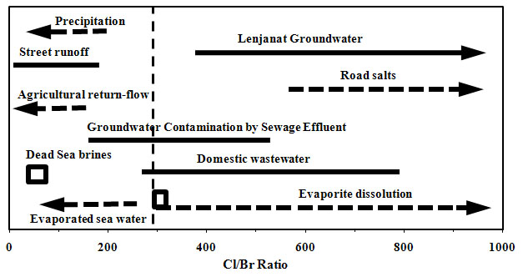
Figure 4. Ranges of Cl/Br ratio in Lenjanat groundwater samples and compare it with values obtained in other researches (modified from [11])

The values of Cl/Br ratio in the study groundwater is due to significant difference in Cl and Br concentrations. In general, Cl/Br ratio greatly exceeding 200 suggests the existence of sources of Cl to the aquifer, which may be either natural or anthropogenic [3]. Compared to low concentration of bromide and its gradual increase, high concentration of chloride and trend of its rapid increase in groundwater flow direction are apparent in the diagram of Cl/Br vs. Cl (Fig. 5). Wide range of chloride concentration and its increase is showed by three separate ranges (Cl<60 mgL⁻¹, 60<Cl<600 mgL⁻¹ and Cl>600 mgL⁻¹) in the diagram. This evolution begins from B.W5 and B.W6 wells (Cl<60 mgL⁻¹) in borders and ends in wells at middle part of the plain (Cl>600 mgL⁻¹).
Bromide concentration increases from 0.04 mgL⁻¹ in the plain borders to 1.72 mgL⁻¹ in center. Slight and gradual increase of Br concentration in the study aquifer can be resulting of organic oxidation in fine grain sediments. Due to Br large ionic size, its ion is not complied in halite mineral structure, thus, halite dissolution will produce a rapid increase in Cl/Br ratios with increasing Cl concentrations [5]. This trend is apparent in samples near the line 1:1 (wells in center of Lenjanat plain) at Fig. 5.
According to mentioned geochemical evidence, the dissolution of evaporation deposits with rock/water interaction (cation exchange) is the main factor for groundwater salinity in study area. Mass ratios of conservative elements Cl/Br in Lenjanat groundwater confirms the reported Cl/Br ratios for groundwater affecting by the dissolution of evaporation deposits (Cl/Br>300) and overlap with range of Cl/Br ratios for domestic sewage effluent groundwater.
5. Conclusion
The results showed that hydrogeochemical properties of the study aquifer are controlled by rock/water interactions include ion exchange, dissolution of evaporation deposits (halite and gypsum) and precipitation/dissolution of carbonates. Based on this and the values of Cl/Br ratio in Lenjanat groundwater (329-4492), dissolution of evaporation deposits in aquifer is the main cause for groundwater salinity. With considering the Lenjanat groundwater geochemical properties, these data confirms the reported Cl/Br ratios for groundwater affecting by the dissolution of evaporation deposits (Cl/Br>300) and overlap with range of Cl/Br ratios for domestic sewage effluent groundwater.
Using stable isotopes and their ratios is reliable estimate to distinction between natural and anthropogenic resources affecting groundwater salinity. However, the cost of measuring non-isotopic elements in water is lower and similarity reduction between data is possible by using bivariate plots and calculation of mass ratios with try and error method. Accordingly, selecting the best chemical components and their ratios in non-isotopic geochemical methods provides an accurate distinction between sources of groundwater salinity.

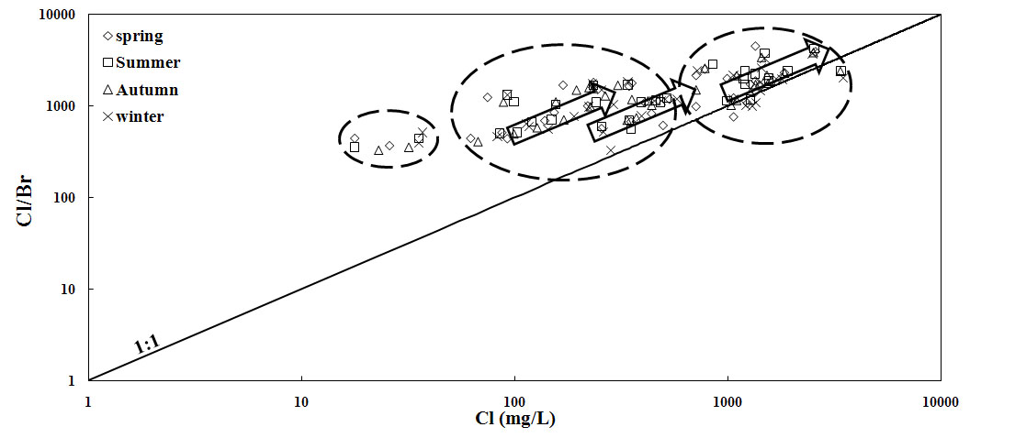
Figure 5. Variations of Cl/Br ratios vs. increasing the concentration of Cl in Lenjanat groundwater. Halite dissolution has produced a rapid increase in Cl/Br ratios with increasing Cl concentrations

References
- B.C. Richter and C.W. Kreitler, Geochemical Techniques for Identifying Source of Ground-Water Salinization, C.K.Smoley, 1993.
- S.N. Davis, D.O. Whittemore and J. Fabryka-Martin,“Uses of Chloride/Bromide ratios in studies of potable water,” Groundwater Journal, Vol. 36, pp. 338-350, 1998.
- S.N. Davis, L.D. Cecil, M. Zreda and S. Moysey, “Chlorine-36, bromide, and the origin of spring water,” Chemical Geology, Vol. 179, pp. 3–16, 2001.
- A. Mariel and A. Vengosh, “Sources of salinity in ground water from Jericho area, Jordan valley,” Groundwater Journal, Vol. 39, pp. 240-248, 2001.
- I. Cartwright, T.R. Weaver and L.K. Fifield, “Cl/Br ratios and environmental isotopes as indicators of recharge variability and groundwater flow. An example from the southeast Murray Basin, Australia, ” Chemical Geology, Vol. 231, pp.38–56, 2006.
- I. Cartwright, S.h. Hall, S. Tweed and M. Leblanc, “Geochemical and isotopic constraints on the interaction between saline lakes and groundwater in southeast Australia, ” Hydrogeology Journal, Vol. 17, pp.1991–2004, 2009.
- L.D. Slater, A. Binley and D. Brown, “Electrical imaging of fractures using ground-water salinity change,” Groundwater Journal, Vol. 35, pp.436-442, 1997.
- D.G. Hopkins and J.L. Richardson, “Detecting a salinity plume in an unconfined sandy aquifer and assessing secondary soil salinization using electromagnetic induction techniques, North Dakota USA,” Hydrogeology Journal, Vol. 7, pp. 380–392, 1999.
- J.G. Paine, “Determining salinization extent, identifying salinity sources, and estimating chloride mass using surface, borehole, and airborne electromagnetic induction methods,” Water Resources Research, Vol. 39, pp. 1-10, 2003.
- W.M. Edmunds and P.L. Smedley, “Residence time indicators in groundwater: the East Midlands Triassic sandstone aquifer,” Applied Geochemistry, Vol. 15, pp. 737-752, 2000.
- A. Vengosh and I. Pankratov, “Chloride/Bromide and Chloride/Fluoride ratios of domestic sewage effluents and associated contaminated ground water,” Groundwater Journal, Vol. 36, pp. 815-824, 1998.
- P.F. Hudak, “Chloride/bromide ratios in leachate derived from farm-animal waste,” Environmental Pollution, Vol. 121, pp. 23–25, 2003.
- B.C. Richter, C.W. Kreitler, “Identification of sources of ground-water salinization using geochemical techniques,” U.S. Environmental Protection Agency, 1992.
- Geological Survey of Iran, “Geological Map of Iran 1:100000 Series, Sheet 6354 Shahreza, ” Ministry of Industry and Mines, 1976.
- Geological Survey of Iran, “Geological Map of Iran, 1:100000 Series, Sheet 6254 Riz-e-Lenjan,” Ministry of Industry and Mines, 1976.
- Ministry of Energy, “The report of geophysical studies in Mobarakeh (Isfahan). Department of Groundwater, 1985.
- M.A. Jafarian, “The project of soils studies in Mobarakeh Steel Co.,” Isfahnan University, 1985.
- Parsabe Sepahan Andish, “The project of contaminants recognition in Zarinshahr,” Thirteen Volumes Zarinshahr Municipality, 2008.
- USEPA, “Groundwater sampling SESDPROC-301-R1, SESD operating procedure for groundwater sampling, ” United State Environmental Protection Agency, 2007.
- USGS, “Field measurement TWRI Book 9,” United State Geological Survey, 2006.
- P.L. Younger, Groundwater in the environment: An introduction, Blackwell, 2007.
- D.L. Parkhurst and C.A.J. Appelo, “PHREEQC (Version 2.18), A Hydrogeochemical Transport Model,” 2005.
- P.J. Stuyfzand, “A New hydrochemical classification of water types,” IAHS Publ No. 182, 1989.
- Iran Steel Co., “Geological and lithological section of wells,” Department of Engineering Geology, 1973.
- A.W. Hounslow, Water Quality Data, Analysis and Interpretation, Lewis Publication, 1995.
- D. Langmuir, Aqueous environmental geochemistry, Prentice-Hall, 1997.
- C.W. Fetter, Applied Hydrogeology, CBS Publishers, 2000.
- W.M. Alley, Regional groundwater quality, Van Nostrand Reinhod, 1993.

